**Precision and Recall**

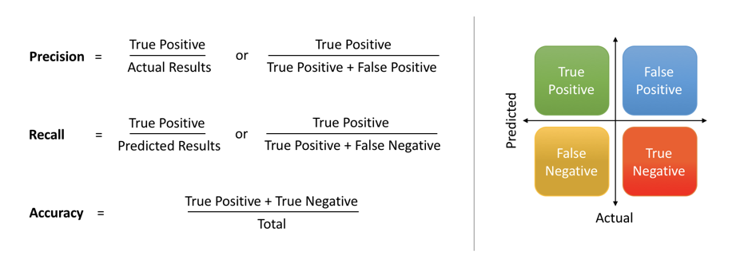

**F Score**

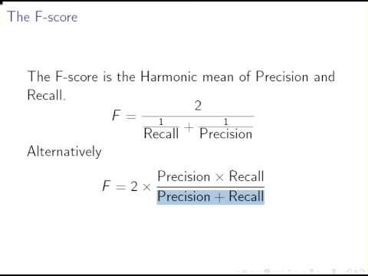

**ROC Curve:**

ROC curve usually used to find the performance of a binary classifier. The classifier with two outcomes

The x-axis showing 1 – specificity (= false positive fraction = FP/(FP+TN))

The y-axis showing sensitivity (= true positive fraction = TP/(TP+FN))

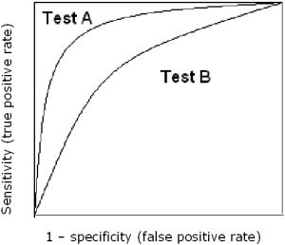

A is superior to test B because at all cut-offs the true positive rate is higher and the false positive rate is lower than for test B.